**Project 1 - Deploying a Multi-Tier Website Using AWS EC2.**

1. Launch an EC2 Instance.

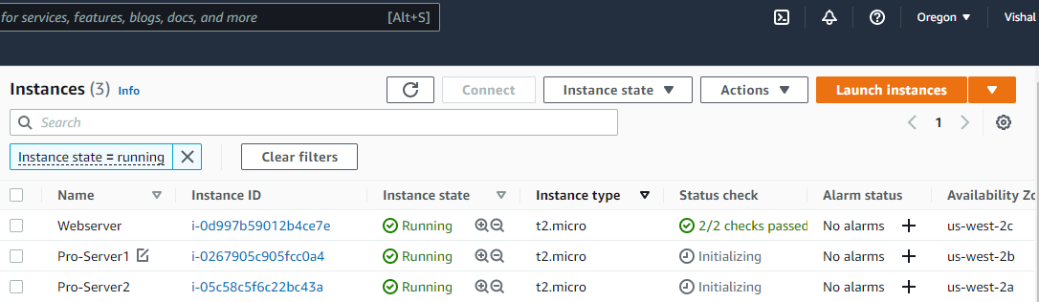

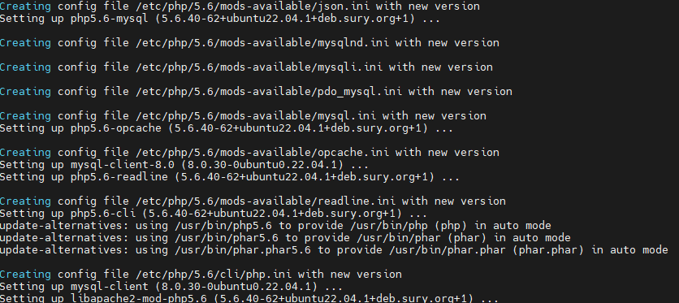

**2. Enable Auto Scaling on these instances (minimum 2)**

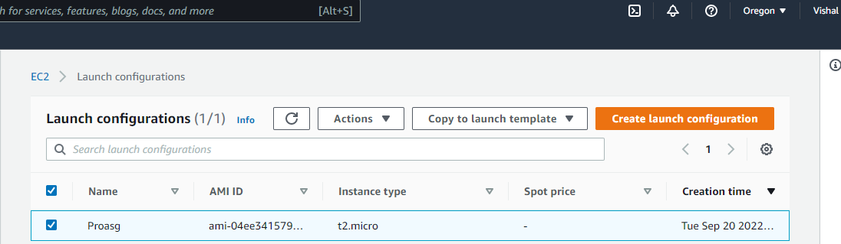

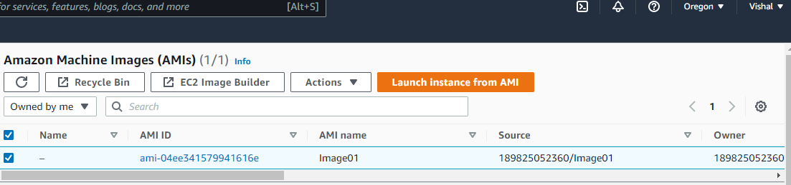

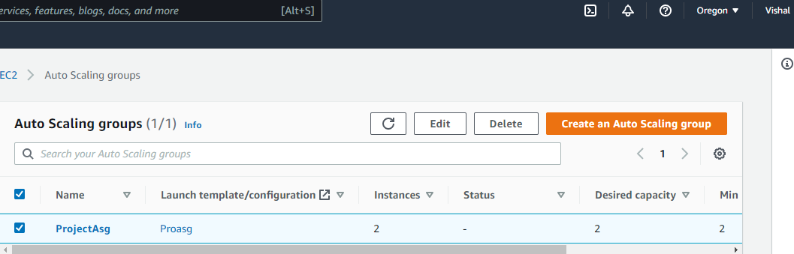

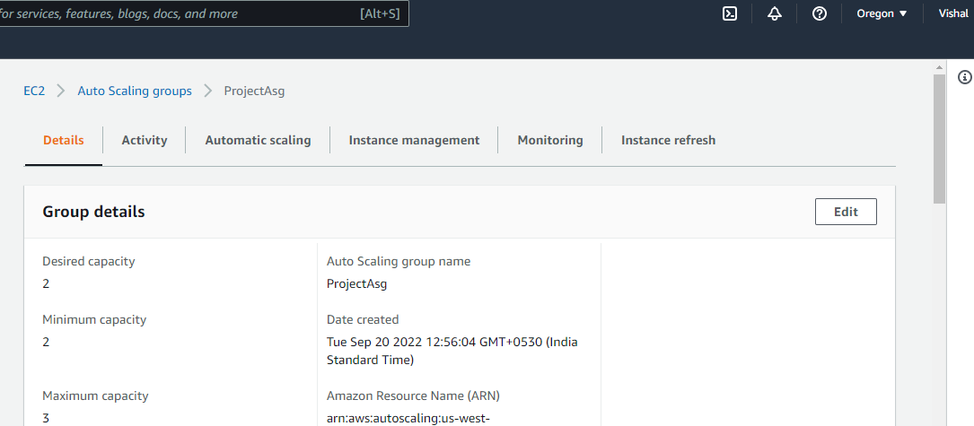

**3. Create an RDS Instance.**

